SECTION JC

ENGINE LUBRICATING OIL PUMPS

CONTENTS

|  |  |
| --- | --- |
|  | Chapter |
| Removal and Dismantling .. | 1 |
| Inspection | 2 |
| Assembly and Fitting | 3 |

CHAPTER 1

REMOVAL AND DISMANTLING

1. The lubricating oil pump assembly consists of two gear type pumps and an idler gear carried in a common housing secured to the underside of the crankcase at the drive-end of the engine.

Removal

1. Remove torsional vibration damper (Section FG).
2. Remove lubricating oil cooler (Section KF).
3. Remove bolts and setscrews securing the free-end cover to the crankcase and lubricating oil sump, and draw the cover off its locating dowels.
4. Remove lubricating oil sump (Section FH).
5. Bend back tabwashers and release setscrews securing suction strainer and piping to the pump end covers and main bearing cap tie bar. Remove suction strainer and piping.
6. Release the support bracket for the lubricating oil delivery pipe and remove the pipe, drawing it out of engagement with the lubricating oil pump delivery connection.
7. Bend back tabwashers and release setscrews and nuts securing the pump body to the crankcase, and draw the complete pump assembly off its locating dowels.

Dismantling

1. Remove the pipe connecting the lubricating oil pump deliveries.
2. Place a suitable hard wood dowel or brass drift between the teeth of idler gear (2) (Fig JC.l) and pump driving gears (17) to prevent rotation.
3. Bend back tabwashers (18), remove nuts (19) and draw gears (17) off the pump driving spindles. Remove drive keys (23).
4. Bend back tabwashers (29), release setbolts (30) and remove retaining plate (1). Remove idler gear (2) off stubshaft (5). Remove the stubshaft from the housing.
5. Bend back tabwashers (32) and remove setscrews (31) securing fixed spindles (24) to suction covers (10).
6. Bend back tabwashers (9), remove setbolts (8) securing suction end covers (10) and draw the covers off locating dowels (12).
7. Withdraw driving and driven rotors (15) and (26). Remove fixed spindle (24).
8. Bend back tabwashers (21), release setscrew (20) and draw gear end covers (25) off locating dowels (27).
9. Remove chip plug (34) from idler gear oilway.

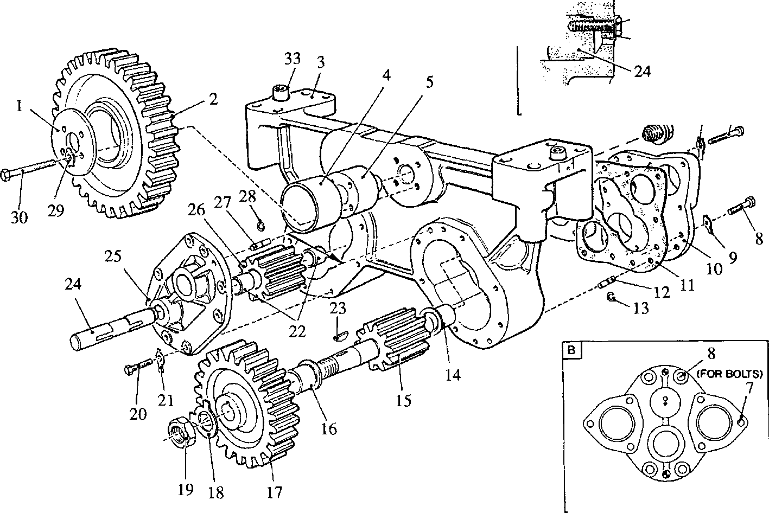

31

32

**METHOD OF LOCKING FIXED SPINDLE**

**POSITION OF SUCTION COVER BOLTS**

**SPD00345**

Key to Numbers.

1. Retaining plate
2. Idler gear
3. Pump housing
4. Bush
5. Stubshaft
6. Tabwasher
7. Setbolt, 50mm long

8 Setbolt, 35mm long

1. Tabwasher
2. Suction end cover
3. Joint
4. Dowel
5. Spring clip
6. Shouldered bush
7. Driving rotor
8. Flanged bush
9. Drive gear
10. Tabwasher
11. Nut
12. Setscrew
13. Tabwasher
14. Bush
15. Drive key
16. Fixed spindle
17. Gear end cover
18. Driven rotor
19. Dowel
20. Spring clip for dowel
21. Tabwasher
22. Setbolt
23. Setscrew
24. Tabwasher
25. Dowel
26. Chip plug

Fig JC.l Lubricating oil pump assembly

CHAPTER 2

INSPECTION

1. Check all dimensions, where possible, against those quoted in the Schedule of Clearances and Wear Limits (Section CD).
2. Examine the bearing surfaces of the idler gear stub shaft and pump rotor spindles for scoring. Blend out any such marks with a fine oilstone. Measure the diameters. Check that oilways and grooves are free from obstruction and damage.
3. Check all bearing bushes for scoring. Light score marks may be blended out with a scraper. Measure the bores.
4. Examine the thrust faces of the idler gear, pump housing, retaining washer and end faces of the rotors for scoring.
5. Thoroughly clean the pump housing and end covers, and check that all oilways and grooves are free from obstruction. Examine the sealing faces for marks and indentations which may impair sealing.
6. Check all dowels and dowel holes for fretting. Examine setscrews and drive keys for serviceability.

Lubricating oil pump wear limitations.

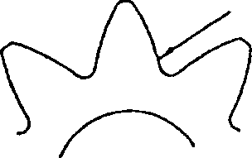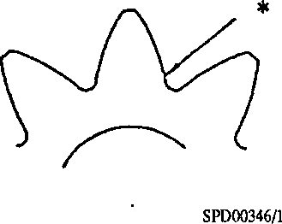2.7. oil pump rotor - wear stages and refit limits:-

*

1. Light Wear - Gear suitable for refitting.

Slight scuffing of loaded flank of gear, possible some scoring by foreign particles in oil. Wear not sufficient to alter profile, or to produce any evidence of a ridge at the inner end of the loaded flank or evidence of interference with tip of mating gear, inspect all flanks.

* No evidence of ridge or interference with tip of mating gear.

More Severe Wear - Gear not suitable for refitting.

2.7.2

Scuffing of loaded flank of gear with evidence of a ridge at the inner end of the loaded flank. Inspect all flanks.

* Evidence of ridge with scuffing of loaded flank.

1. Advanced Wear - Failure likely in foreseeable future.

Severe scuffing from tip of gear to approximately half way down the active profile with pitting in the pitch line zone. The condition will result in high load on drive system. Gear should not be refitted. Inspect all flanks.

* Pitting visible here, with severe scuffing above.

1. More Advanced Wear - Failure likely in the immediate future.

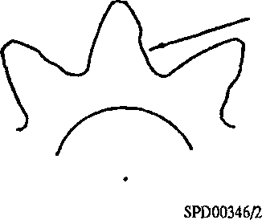Wear to the extent that alteration to profile is visible when gear is viewed on end face. Gears run in this condition will impose extremely high loads on the drive system. Failure will occur either by tooth breakage or failure of drive due to high loads. Inspect all flanks.

* Alteration of profile or broken tooth clearly visible.

1. Lubricating Oil Pump Body - Wear Limits.

Scoring of oil pump body in area of rotor tips caused by debris being drawn through the suction strainer not make the pump body unfit for use unless it is extremely severe. It should be noted that the appearance of the pump body bore will be far worse than actual measurement will reveal. Measure pump rotor bores.

When new the pump body rotor bores are as follows:-

12 Cylinder Engines (Twin Rotor Pumps)

76.175 to 76.225 mm (2.999 to 3.001 in)

If not more than 0.127 mm (0.005 in) oversize, the pump body is fit for further use.

1. Oil Pump End Covers.

Scoring of end covers is much more significant than scoring of pump body as leakage path is shorter and more direct. Only light scoring can be tolerated.

CHAPTER 3

ASSEMBLY AND FITTING

NOTE All joints and 'O' rings must befitted dry.

1. The following procedures are based on the assumption that the pump assembly has been completely dismantled for component renewal.

NOTE Suction end covers (10) (Fig JC.l) are sealed to the pump body with joints (11), while the gear end covers (25) are sealed to the pump body with 'Plastic Gasket 16113’.

Assembly

1. Press flanged bush (16) into end covers (10) and (25). Ensure that the longitudinal groove in the bush bores is towards the fixed spindle bore and that the bush flanges are fully bedded in the cover recesses. Ream the bush bores to the dimension quoted in the Schedule of Clearances and Wear Limits (Section CD)
2. Press bushes (22) into the bore of driven rotor (26). Ensure that the bushes are flush with the end faces of the rotor. The bushes are pre-finished and DO NOT require reaming.
3. Press bush (4) into the bore of idler gear (2). Ensure that the bush is below the end faces of the gear hub. The bush is pre-finished and DOES NOT require reaming.
4. Fit fixed spindles (24) to suction covers (10) ensuring that the tapped hole in the stepped end of the spindle aligns with the setscrew hole in the cover. Fit setscrew (31) (Inset A) together with new tabwasher (32), tighten setscrew and bend up tabwasher.
5. Fit spring clips (13), to dowels (12), and fit the four dowels to suction cover side of pump housing.
6. Using new joints (11), fit suction covers (10) to the pump housing and temporarily secure each cover with ten setbolts 35mm long. DO NOT FIT TABWASHERS.

NOTE When finally assembled and the pump fitted to the engine, each suction cover is secured by four setbolts (8) 35mm long and tabwashers (9), and six setbolts (7) 50mm long and tabwashers (6). The longer setbolts also secure the suction and delivery pipe flanges.

1. Invert the pump housing and insert the driving and driven rotors (15) and (26). Check the depth of the rotors below the gear end cover sealing faces. This should be 0.10 to 0.15mm (0.004 to 0.006in).
2. Fit spring clips (28), to dowels (27) and fit the four dowels to the gear cover side of the pump housing.
3. Coat the cover sealing faces of the pump housing with Flexible Gasket 16113, fit gear end covers and secure with setscrews (20) and tabwashers (21). Tighten setbolts and check rotors for freedom of rotation. Bend up tabwashers.
4. Using two bolts (30) as guides, fit idler gear stubshaft (5). Remove bolts. Fit idler gear (2) and retaining plate (1) to the stubshaft and secure with bolts (30), and new tabwashers (29). Tighten the bolts to the torque loading quoted in Section CE. Check the idler gear endfloat. This should be 0.20 to 0.43mm (0.008 to 0.017in). Bend up the tabwashers; the legs of the tabwashers engage with the retaining plate bore.

LIMITED RIGHTS LEGEND

USE, DUPLICATION OR DISCLOSURE OF THIS INFORMATION WHICH IS THE PROPERTY **q**

OF GEC ALSTHOM DIESELS LIMITED BY THE U.S. GOVERNMENT (Ml BOLLINGER IS /

SUBJECT TO THE RESTRICTIONS SET FORTH IN DOD FAR SUPP 252.227-7013 (a) 15.

1. Fit drive keys (23) and gears (17) to driving rotor spindles, and fit nuts (19) together with new tabwashers (18).
2. Insert a hardwood dowel or brass drift between the teeth of the idler gear and drive gears to prevent rotation, tighten nuts (19) and bend up tabwashers (18).
3. Remove four setbolts (8) fitted to each of suction cover bolts holes (Inset B), fit tabwashers (9), refit and tighten setbolts and bend up tabwashers.
4. Remove the six bolts fitted to suction connection bolt holes.
5. Remove the six bolts fitted to the delivery connection bolt holes (Inset B). fit the delivery connection pipe and the bolts (7) together with tabwashers (6), tighten bolts and bend up tabwashers.
6. Degrease the threads in the pump housing and magnetic plug with trichloroethane or similar cleaning agent and allow to dry. Coat the plug threads with ’Loctite’ Studlock, screw into housing and tighten.

Fitting

1. Fit pump locating dowels to crankcase, fit pump assembly to crankcase and secure with philidas nuts, setscrews and tabwashers. Tighten nuts and setscrews to the torque loading quoted in Section CE and bend up the tabwashers.
2. Check the backlash between idler gear and crankshaft drive gear is as quoted in Section CD. The backlash must be checked with the engine in the normal upright position, NOT INVERTED.
3. Fit oil suction piping and strainer, securing to lubricating oil pump and main bearing cap tie bar. New 'O' rings should be fitted to the pipe flanges.
4. Using a new 'O' ring, fit the oil delivery pipe to the free-end of the engine and fit the support clamp and bracket.
5. Fit lubricating oil sump (Section FH).
6. Fit free-end cover (Section FH).

Fit torsional vibration damper (Section FG).